- identify challenges, opportunities and recommendation.
- Analyze survey data on strategies to support teaching as a potential career for Indigenous students.
- Analyze data from survey on how members are using Guide.
- Conduct research to support practices in support of findings from both surveys.

- United Nations Declaration on the Rights of Indigenous People – Article 14
- TRC –Calls to Action 6-12 - Reconciliation
- Indigenous Education Reconciliation Circle
- Alberta Education Business Plan 2019-23
- First Nations, Métis, and Inuit Education Action Committee
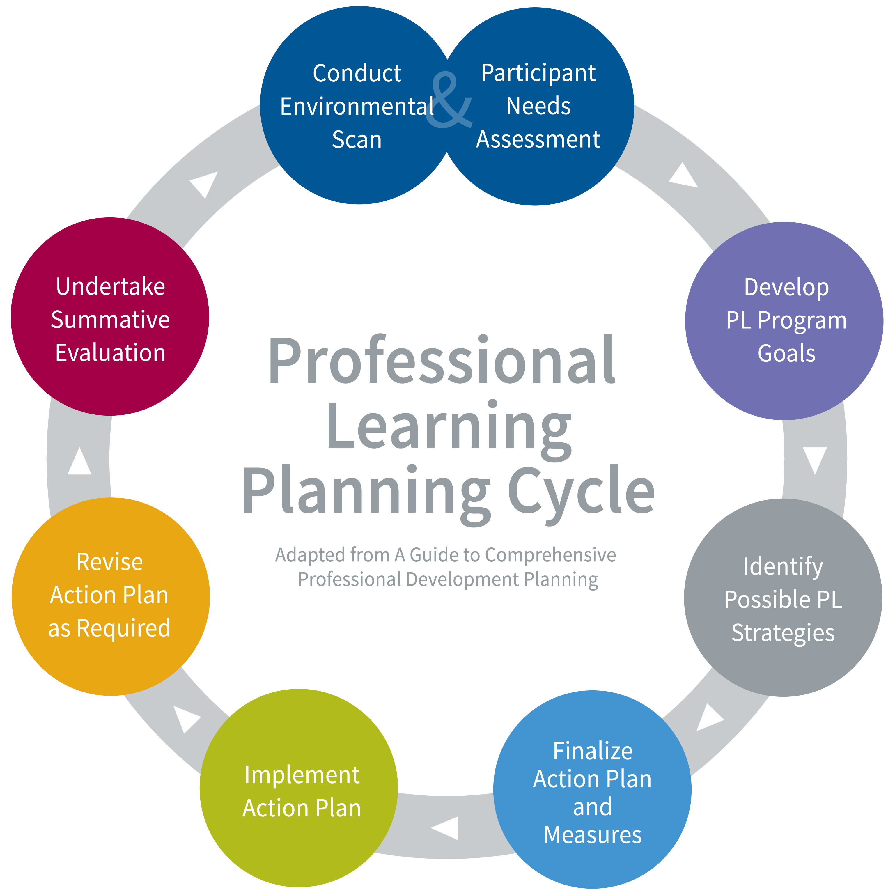
- CASS FNMI Education Action Committee
- Ongoing reporting to Alberta Education
- PD program/planning updates
- Design and administer evaluation to align with program goal.

2020-2021
Ensuring First Nations, Métis and Inuit Education for All Students
- CASS fall/Annual /Gathering/Start Right/Leading for Learning conferences
- Revise Indigenous education Module
- Track access to resources online
- Collaborate with education partners AADE/ATA to share PD and learning
- Formative evaluation is consistent, ongoing.
- Evaluation is shared with members on their learning.

Formative evaluation will track successes/inform revisions and next steps.

Determine if program met its goal and participants’ needs.

- Increase the knowledge and understanding of system leaders to lead Indigenous education in their district.

