- Alberta Education: Business plan, Ministerial order on Student learning, Assurance Framework, New Curriculum
- Covid 19/Pandemic (Continuity of Learning, Workplace Wellness)
- CASS Strategic plan: SLQS professional growth

- Fall 2020 Conference Survey Data (Thought exchange - TE), Data specific to an area of focus (TE Assurance Framework) October 2020
- CASS Members learning needs (TE December 2020)
- SLQS PL Zone representatives
- ARPDC Regional priorities/Provincial Advisory Committee
- WW Environmental Scan and Needs Assessment - Advisory Committee
- New members need served via direct mentoring by experienced members
- Indigenous teacher leader survey
- Committee Reports https://www.cass.ab.ca/communication

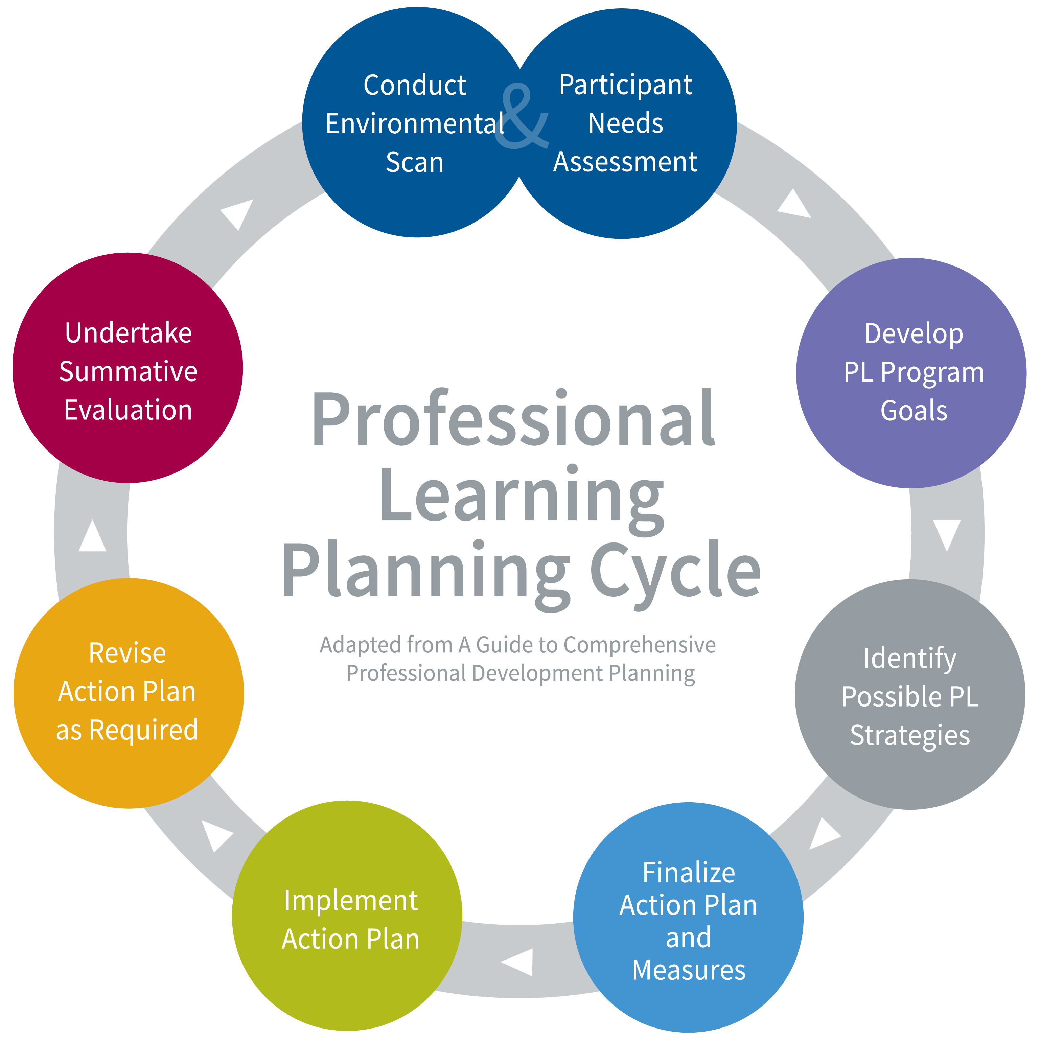

- Continuous improvements – SLQS PL committee & CASS Executive Director and Directors of Leadership Learning
- Report to CASS Board of Directors for direction and approvals/support
- Sustain/continue the learning to support next steps based on data

- Gather, review, analyze data, identify themes, make recommendations for coming year
- Did the plan meet its goals?
- Did the plan meet participants’ needs?

CASS Professional Learning 2020-21
- Conferences, Webinars - Learning Opportunities (Online)
- Resources accessible online at cassalberta.ca E.g., Learning Guides, Workplace Wellness Implementation and Planning Guide, Indigenous Online Guide, Practice Profiles
- 2020- 2021 Calendar

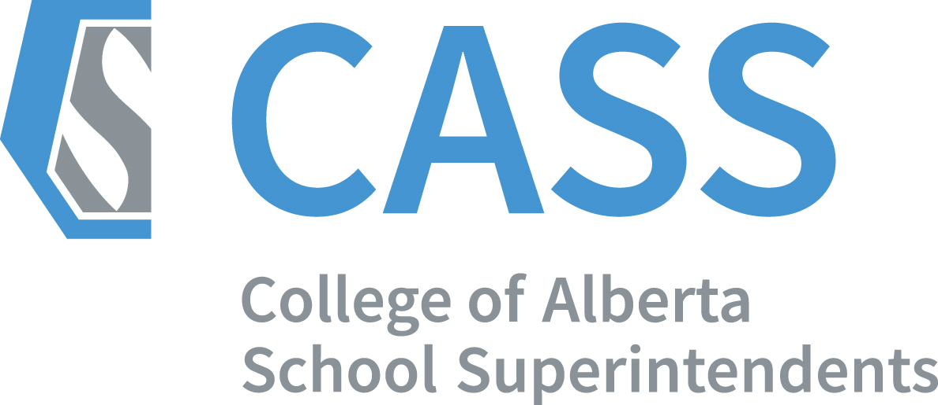
2020-2021
- Share Draft plan with SLQS PL Committee, Board for input and approval
- Design and Deliver
  - Technical requirements/needs/Show flow for online
  - Adult Learning engagement strategies for online or in person
- Evaluate learning opportunity, analyze data for continuous improvements, report findings
- Measures: Quantitative data related to attendance, access to website materials, Thought exchange feedback from learning opportunities, anecdotal feedback
- CASS exists to support and build member’s capacity. (CASS Strategic Plan 2020-23) CASS will lead support for implementation of the Superintendent Leadership Quality Standard (SLQS). The outcome for the work is: Superintendent leadership supports quality school leadership and teaching to create optimum learning for all students in Alberta. Adapted from the SLQS Alberta Education.
- CASS Professional Learning Goal 2020-21 Deepening the understanding and applying the learning to support implementation of professional practice.

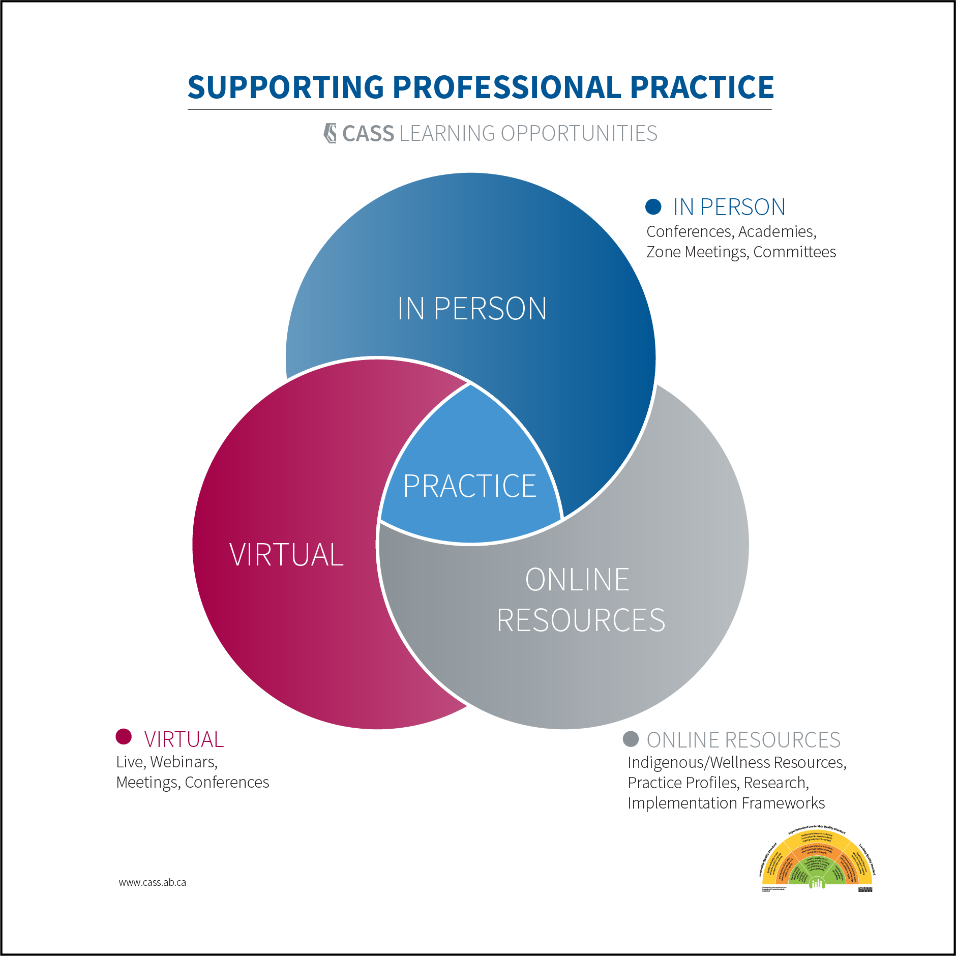

CASS Directors of Leadership Learning - Monitor and Report on Data to seek input and direction from:
- SLQS PL Committee, WW Advisory Committee, First Nations Métis and Inuit Education Action committee, CASS/ARPDC Provincial Advisory committee. CASS Board of Directors.
- CASS Connects/CASS communications share results

Planning using A Guide to Comprehensive Professional Development Planning http://bit.ly/2lDSAm9

This guide is intended to support a process of collaborative conversation among education stakeholders working together to develop a comprehensive plan for professional learning. It is designed with guiding questions to facilitate dialogue and planning. Research continues to show that student learning is enhanced when staff has capacity - implying standards of practice can be enhanced through professional learning. It is believed that a comprehensive plan for professional learning has the potential to develop the capacity of your staff - more so than any individual professional learning opportunity.

This template offers selected questions for consideration in supporting implementation of the quality standards (adapted from A Guide to Comprehensive Professional Development Planning). It also provides space for you to record your group’s responses as a result of dialogue.

Conduct Environmental Scan  - What currently exists that supports quality standards of practice? (e.g. policy, practice, research, supports for professional learning)  - How do your district vision, mission and/or goals support staff capacity?  Participant Needs Assessment  - What data currently exists that identifies professional learning needs? Current staff capacity? (e.g. student learning data, staff survey data, other support organization data)  - How might you collect data on the professional learning needs of your team?  - Can you collaborate with others to collect data? (e.g. CASS, ARPDC, ATA)  Develop PD Program Goals  - Based on your district’s vision and mission, school plans, as well as data analysis of individual needs, what will your goals for professional learning be?  - How will your goals include a focus on both staff capacity and the impact on student learning?  - Are goals different for the district, the school, and the individual staff member?  Identify Possible PD Strategies  - Which professional learning designs best suit the diverse needs of your team?  - What professional learning opportunities are offered by other organizations? (e.g. CASS, ATA, ARPDC, AAC, post secondary programs) | Identify Possible PD Strategies (continued)  - How will professional learning be ongoing and sustained?  - How will the impact of your professional learning plan be measured?  Finalize Action Plan and Measures  - Does the plan contain goals, learning designs and strategies, ways to measure impact and the necessary resources to actualize the plan?  - How will the plan be communicated? Resourced?  - What will you accept as evidence that staff capacity has been enhanced?  Implement Action Plan  - Based on the stakeholders involved in developing the plan, how will they continue to be involved in supporting implementation and monitoring impact?  - How often will you collect and analyze data to know your efforts are having an impact?  Revise Action Plan as Required  - Based on data you have collected and analyzed, how will you adapt your plan?  - Is the comprehensive plan influencing practice and student learning?  Undertake Summative Evaluation  - Did the plan meet its goals? (e.g. student learning)  - Did the plan meet participants’ needs? (e.g. enhanced practice)

