
School System Leadership Development: A Learning Guide

This Learning Guide is intended to support superintendents and system leaders with a process for enhancing school authority leadership capacity. This guide leverages the best practices from CASS research reports that focus on leadership development and are available at: https://cassalberta.ca/resources/research-and-position-papers/.
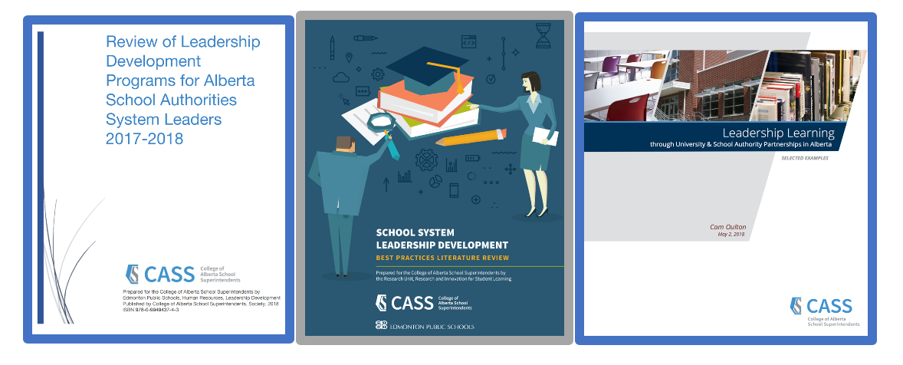

A Guide to Comprehensive Professional Development Planning and A Guide to Support Implementation: Essential Conditions provide a collaborative process to enable school authorities to plan leadership development learning opportunities based on school authority contexts. https://cassalberta.ca/planning-for-implementation/


CASS supports the Superintendent Leadership Quality Standard from Alberta Education, which provides a common frame of reference for defining professional practice. CASS professional learning opportunities and resources support superintendents and system leaders in building their professional practice capacity in order to support quality school leadership and teaching to create optimum learning for all students in Alberta.

Professional Practice Connections for Superintendents and System Leaders

For superintendents - building leadership capacity aligns with the Superintendent Leadership Quality Standard (Alberta Education 2018), specifically the following competencies and indicators:

- Modeling Commitment to Professional Learning - A superintendent engages in career-long professional learning and ongoing critical reflection, identifying and acting on research-informed opportunities for enhancing leadership, teaching and learning.

Indicators “such as”:
b. collaborating with teachers, principals and other superintendents to build professional capacities and expertise; and
d. seeking and critically reviewing educational research and applying it to decisions and practices, as appropriate.

- Leading Learning - A superintendent establishes and sustains a learning culture in the school community that promotes ongoing critical reflection on practice, shared responsibility for student success and continuous improvement.
Indicators “such as”:
- providing learning opportunities, based on research-informed principles of effective teaching, learning and leadership, to build the capacity of all members of the school community to fulfill their educational roles;
- promoting collaboration, critical thinking and innovation in the school community;
- ensuring that staff have access to resources, programs and expertise to support them in meeting their professional responsibilities and in addressing the learning needs of all students; and
- building principals’ capacities and holding them accountable for providing instructional leadership through effective support, supervision and evaluation practices.

Connections with all competencies is implied as they are interrelated and interdependent. For the purposes of this learning guide the focus will be on these two specific competencies.

For system leaders - building leadership capacity aligns with the CASS System Education Leader Practice Profile as described by the following competencies and indicators:

- Modeling Commitment to Professional Learning - A system leader engages in career-long professional learning and ongoing critical reflection, identifying and acting on research-informed opportunities for enhancing leadership, teaching and learning.

Indicators “such as”:
b. collaborating with teachers, principals and other superintendents to build professional capacities and expertise; and
d. seeking and critically-reviewing educational research and applying it to decisions and practices, as appropriate.

- Leading Learning - A system leader facilitates and sustains a learning culture in the school community that promotes ongoing critical reflection on practice, shared responsibility for student success and continuous improvement.
Indicators “such as”:
b. providing learning opportunities, based on research-informed principles of effective teaching, learning and leadership, to build the capacity of all members of the school community to fulfill their educational roles;
d. promoting collegial relations, collaboration, critical thinking and innovation in the school community; and
e. ensuring that staff have access to resources, programs and expertise to support them in meeting their professional responsibilities and in addressing the learning needs of all students.

- Sustaining Effective Instructional Leadership - A system education leader ensures that every student has access to quality teaching and optimum learning experiences.

Indicators “such as”:
- building the capacity of teachers, principals and other system leaders to respond to the learning needs of all students;
- facilitating authority-wide professional growth, supervision and evaluation processes to ensure that all teachers, principals and other system leaders meet their respective professional practice standards;
- facilitating mentorship and induction supports for teachers, principals and other system leaders in the school authority as required; and
- supporting principals, other system leaders and superintendents in providing opportunities for members of the school community to develop leadership capacity;
i. promoting a school authority-wide culture of collaboration, excellence and professionalism.

CASS Commissioned Research Reports - Highlights

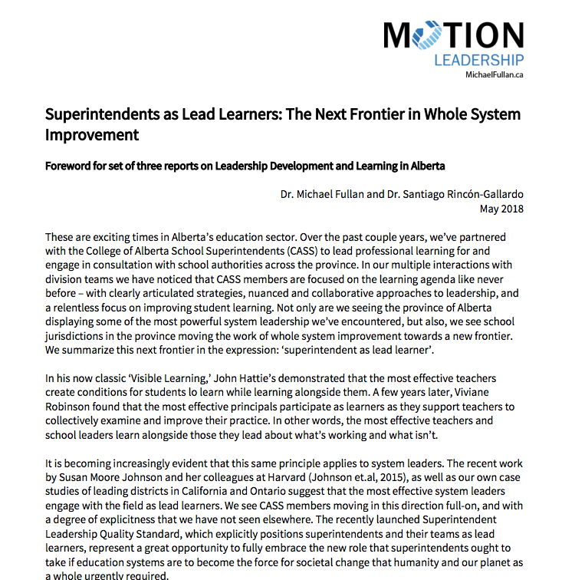
Review of the Research on Quality Leadership Development Programs and Practices
https://cassalberta.ca/resources/research-and-position-papers/

In 2018, CASS commissioned three projects to support system leadership development programs and practices. A summary of the work was provided in a foreword written by Dr. Michael Fullan and Dr. Santiago Rincón-Gallardo:

Superintendents as Lead Learners: The Next Frontier in Whole System Improvement. Foreword for set of three reports on Leadership Development and Learning in Alberta.

Fullan and Rincon-Gallardo note that CASS members are focused on a learning agenda like never before with clearly articulated strategies, nuanced and collaborative approaches to leadership and a relentless focus on improving student learning.

- System leaders, like principals, are most effective when they participate as learners as they support those they lead to collectively examine and improve their practice - they learn along with school leaders what’s working and what isn’t.
- With the new SLQS, superintendents and system leaders have a great opportunity to embrace the role of lead learners to move the work of whole system improvement.
- A force for system transformation is created when leaders liberate and support those they lead, collaborate and connect laterally with other leaders to learn from and support each other, and leverage and influence the system above them.

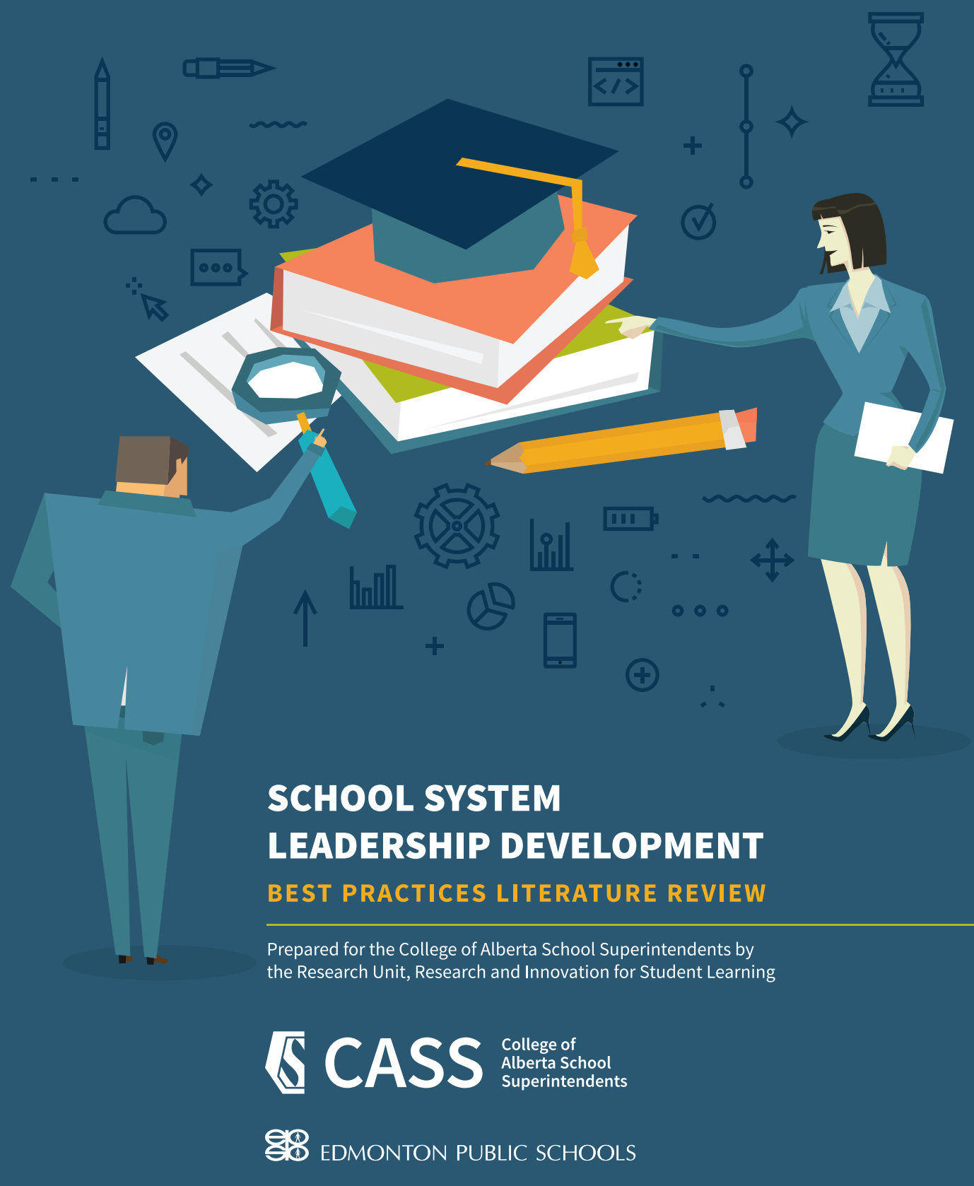
Literature Review on the Best Practices in Leadership Development

Five key areas from the CASS literature review highlight the importance of the following promising practices:
- focusing on high impact strategies (e.g. instructional leadership);
- grounding decision making on evidence and research;
- maintaining a diversity in approaches and resources to respond to the context and needs of each leader and school authority;
- attending to cultural needs for students’ success; and
- treating the SLQS competencies as interwoven and interdependent.

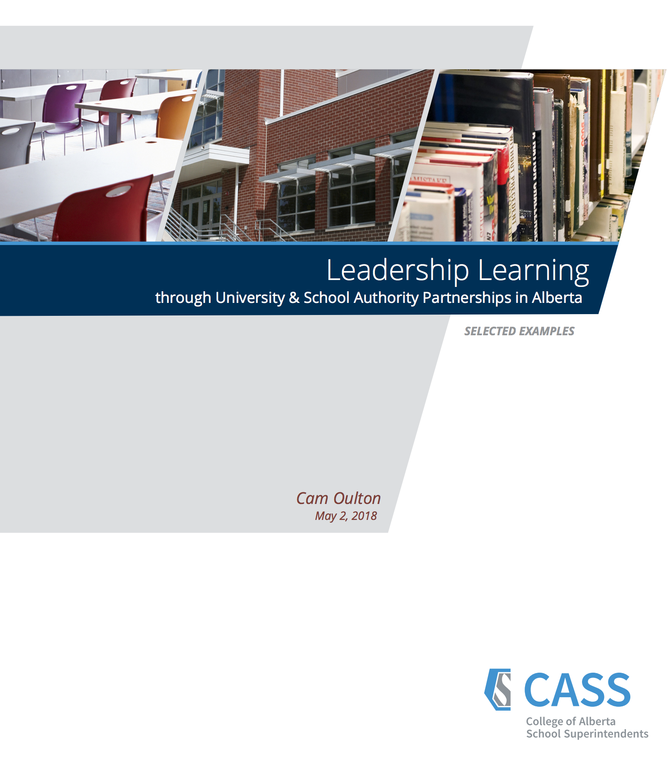
A Report on Leadership Learning through University-School Authority Partnerships
Highlights of three-year partnerships established between seven school districts and two universities (Calgary and Lethbridge) are summarized in this report. It describes strong expertise already in existence within Alberta on how to effectively nurture and develop university and school authority partnerships that positively transform the culture of the school authority and enhance student learning system-wide.
Based on these seven showcased university and school authority partnerships the report highlights the value in working together as:
- increased trust;
- increased credibility;
- bridging theory and practice;
- exposure to adult learning practices; and
- focused external expertise.

Common themes in the report highlight the importance of:
- joint determination and development of program (research and practice);
- attention to the competencies in the SLQS/LQS;
- development of leadership teams (school district and university); and
- opportunities for graduate program participation.

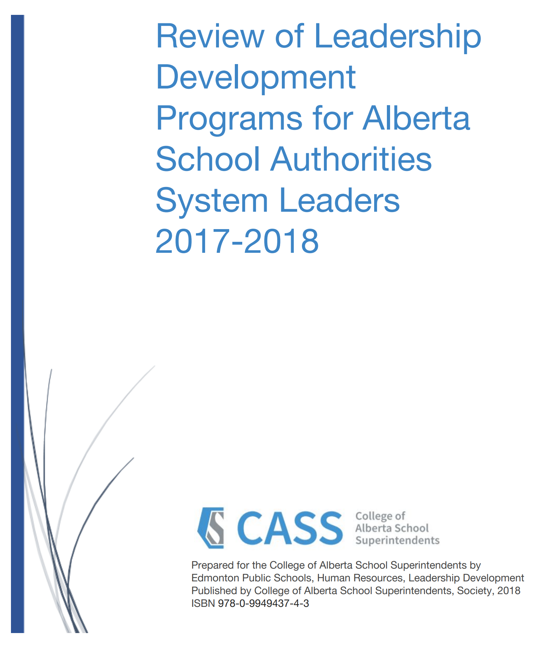
A Review of Alberta District Leadership Development Programs (a catalogue of current programs from over 50 school authorities)
Over 50 school authorities in Alberta provide highlights of leadership development programs focused on preparing new and current school leaders (e.g. principals and assistant principals) and on leadership development programs for system leaders. Authorities are open to sharing their work and have a strong desire to hear and learn from others. Networking with other school authorities offers opportunities to problem-solve, communicate and connect together.

This catalogue of leadership development programs is organized by the following leadership roles:
- general programs to build leadership capacity (for various positions);
- assistant principal preparation programs;
- principal preparation programs;
- new principal programs;
- new assistant principal programs;
- current principal programs;
- current assistant principal programs; and
- other system leader programs.
What other sources of educational leadership development research is your school authority using to guide leadership development work?
Edmonton Public Schools completed a literature review titled Principals as Instructional Leaders: A Review of the Literature.

In this literature review, conducted by Edmonton Public Schools in 2018, the following were key findings of exemplary leadership programs:

- Clear definition of instructional leadership and the identification of skills needed is foundational for robust principal leadership.
- Meaningful, high quality supports for principals that integrate adult learning principles, field experience, and selective recruitment evaluation are required.
- Coaching and mentoring provide intensive support for new and experienced principals to help overcome career challenges and innovate practices.
- Stressors, workload and dedicated time for leadership development needs to be considered in programs and opportunities.

Creating a Leadership Development Program – strategies to consider

Establishing a Leadership Development Committee

Gathering critical leaders and various stakeholders (e.g. principals, assistant principals, system leaders) for collaborative conversations to design and develop plans for building and enhancing leadership capacity is important. Successful implementation requires the coordinated, collective and comprehensive efforts of stakeholders working together toward a shared vision of learning success for all students, based on developing the capacity of leaders.

A leadership development committee that includes various stakeholders provides an excellent opportunity to hear about the learning needs of various members as well as create engagement and support for the program based on committee involvement.

Process Considerations for Successful Committee Work

Many processes to engage the committee lend themselves to collaborative thinking and rich dialogue that move the work forward. System leaders best understand the unique context of their school authorities and the expertise of individual members chosen for the committee.

Acknowledging that the work of the committee may require several conversations over time to determine thoughtful, strategic decisions and actions when using one or both of these models for enhancing leadership capacity, it is important to consider how the committee will work together. It is recommended that setting the stage for the first and subsequent committee meetings include determining and articulating group norms, expectations, intentions and desired outcomes.

Plans to Support Professional Learning Design and Implementation

The guided questions suggested in the following models are intended to be used by a committee. The models nurture dialogue by committee members based on reflection on needs and current context and exploration, and decisions for the creation of a leadership development program. The outcome of using both models is to create a collaborative process for designing a plan for professional learning and implementation.

The questions in this learning guide have been accessed and adapted from A Guide to Support Implementation: Essential Conditions and A Guide to Comprehensive Professional Development Planning. Superintendents, system leadership and committee members may wish to add additional questions to reflect their context and experiences. Source documents, including planning templates are available at CASS - “Planning for Implementation”: https://cassalberta.ca/planning-for-implementation/.

Which model to use?
CASS believes that planning for implementation comes prior to planning for professional learning. However, starting with planning for professional learning is a practical step that produces a visible product. Just planning for professional learning but not implementation will leave a void in achieving the outcomes and intent of the professional learning – to build the capacity of leaders in your school authority.

Model One: Essential Conditions for Effective Leadership Development

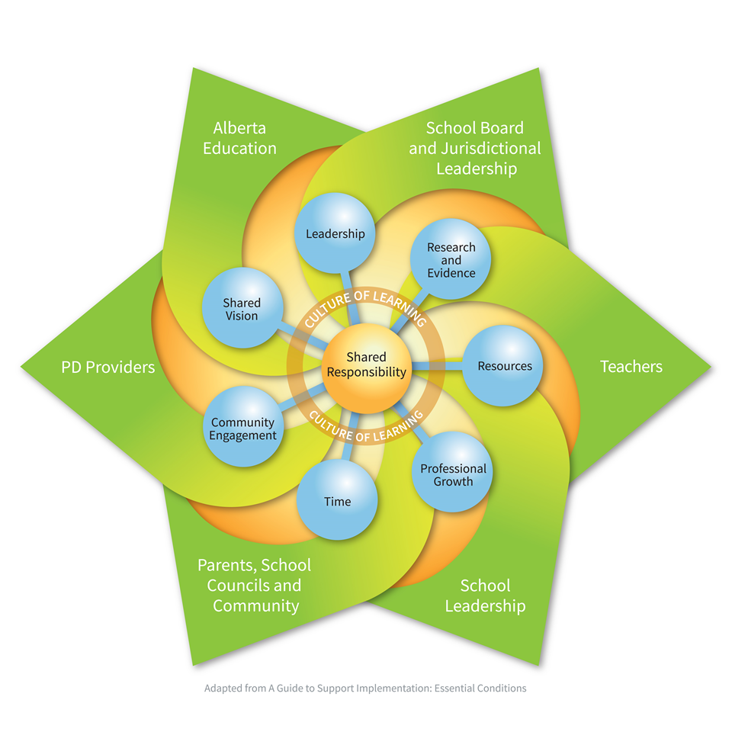

A Guide to Support Implementation: Essential Conditions
Successful implementation is possible in environments where education stakeholders are committed to sharing the responsibility for supporting implementation within a culture of learning.

Essential  Condition | Guiding Questions for Reflection and Exploration *  Pick and choose questions most appropriate for your context. Add additional questions as required. | Actions/next steps to Address this Essential Condition
Shared Vision  Stakeholders share an understanding of and commitment to the intended outcomes. | Why do we need/want a leadership development program?  What are our core beliefs about the purpose of developing leadership capacity?  What is our intended outcome for our leadership development program?  How can we articulate the vision /outcomes for our work?
Leadership  Leaders at all levels have the capacity to champion the shift from the current reality to the intended outcomes. | How do we collectively define high quality leadership for our district?  What are the key words, descriptors or components of high-quality leadership?  What do we believe to be the core values of an outstanding leader in our district?  Building on our collective beliefs about leadership how might we articulate this in our program? To current and aspiring leaders?  What do we know about our emerging and future leaders as learners? How does this impact our work?
Research and Evidence  Current research, evidence, and lessons learned inform implementation decisions. | What evidence do we have that measures how our efforts are resulting in quality leadership?  What story does the current data tell about our current and emerging leadership?  (e.g. employee demographics, survey, achievement)  How will this evidence and data move us forward?  Besides the CASS research  What other research do we want to consider to inform our implementation decisions?
Research and Evidence
Current research, evidence, and lessons learned inform implementation decisions.

CASS Research Projects - School Authority Reflection
https://cassalberta.ca/resources/research-and-position-papers/

A Literature Review on the Best Practices in Leadership Development –  Key Findings | What we do now that is coherent with the research? | What we might consider enhancing in our leadership programs?
Focus on high impact strategies (e.g. instructional leadership)
Ground decision-making on evidence and research
Maintain a diversity in approaches and resources to respond to the context and needs of each leader and school authority
Attend to cultural needs for student success
Treat the SLQS competencies as interwoven and interdependent.

Leadership Learning through University-School Authority Partnerships –  Key Findings | What we do now to partner with post-secondary institutions? | How might we consider enhancing in our current leadership program with post-secondary partners?  Who might we partner with?
Joint determination and development of leadership programs with Universities (research and practice)

Attention to the competencies in the SLQS/LQS

Development of leadership teams (school district and university)

Opportunities for graduate program participation.

Resources  Human resources, materials, funding, and infrastructure are in place to realize the intended outcomes. | Who can provide support and leadership with our next steps?  How might we leverage current or new networks to support our leadership development? (e.g. within our district, other districts, post-secondary institutions)  Given the CASS report Review of Leadership Development Programs for Alberta School Authorities, how can we use this repository of information?  What financial resources do we have and what do we need?  What systems do we have in place for communicating our leadership work? What systems can we access to communicate our plans moving forward?
Leadership Professional Growth  Leaders knowledge, skills and attributes are enhanced through ongoing professional learning. | Given the new Leadership Quality Standard, what competencies are demonstrated well? What competencies need attention and support?  What do we do well to provide learning opportunities to build leadership capacity now and how do we know? (Strengths)  What are areas for professional growth and improvement that we are hearing from our leaders? That we are aware of for future needs?  How are leaders integrating and applying their learning from leadership development? How do we know?
Time  Time is provided to support implementation | What’s working well in how we provide time for learning in leadership development?  What are the roadblocks? What’s another way?
Community Engagement  Parents, school councils, students, community members, businesses, industry and post –secondary institutions are partners in supporting implementation | How might we involve our stakeholders and/or post post-secondary institutions to build leadership capacity?  How will we inform our community about the value we see in our leaders and how we are supporting their capacity?

Model Two: Comprehensive Professional Learning Planning


A Guide to Comprehensive Professional
Learning Planning
For professional learning to be effective it must be systemically planned, systemic, supported and sustained. A comprehensive professional learning plan mindful of these components should result in increased staff capacity and as a result student learning.

This is a step by step approach that will support you in designing a more comprehensive leadership development program.

Step One: Conduct an Environmental Scan and Participant Needs Assessment

Data collected in the first step provides insight into student learning and critical information for instruction including provincial initiatives, programs of study, available resources, student and teacher demographics and other contextual variables. Data for the environmental scan and participant needs assessment can be collected from such sources as existing documents and reports (including student learning and achievement data) and through such processes as participant surveys and focus groups. The following questions will help you through this step of the plan.

Guiding Questions for Reflection and Exploration  Pick and choose questions most appropriate for your context. Add additional questions as required. | Reflections/Responses
What currently exists that supports quality leadership development? (e.g. policy, practice, research, supports for professional learning) What evidence do we have that our leadership development opportunities and practices are effective?

What are the current and emerging needs of our school and system leaders? What data will we use to determine the needs?
How does our district vision, mission and/or goals support building and enhancing leadership staff capacity?

What data currently exists that identifies learning needs of our leaders? Current staff capacity? (e.g. student learning data, staff survey data, employee demographics, other support organization data)

How can our education partners (e.g. CASS, ATA, ARPDC, AAC, etc.) assist with the data?
What trends or themes emerge from the aggregated data?

Step Two: Develop Professional Learning Goals for Enhancing Leadership Capacity

Establishing priorities based on analysis of the data, and developing a manageable number of goals is the next step. Before deciding on what action to take, reviewing the literature and contacting existing and potential partners will assist in considering the best approaches and strategies to achieve the goals.

Based on the district’s vision and mission, school plans, as well as data analysis of individual needs, what will the goals for the leadership development be?

How will the goals include a focus on both staff capacity and the impact on student learning?
How can these goals be developed as SMART goals? (specific, measurable, achievable, realistic and time-targeted)

What resources are needed to effectively address the goals? (human, financial, infrastructure, time)

What are other Alberta jurisdictions doing to develop leadership capacity as referenced in the CASS Review of Leadership Development Programs for Alberta School Authorities System Leaders?
How can we network with other districts or post-secondary institutions to enhance the leadership programs?

Step Three: Identify Possible Professional Learning Strategies

After scanning the environment, assessing participants’ needs and developing goals, consider professional learning designs, strategies and opportunities to enhance leadership capacity. An important step at this stage is to identify evidence required to determine successful program implementation and outcomes.

Which professional learning designs best suit the diverse needs of your school authority?

What professional learning opportunities for leadership development are offered by other organizations? (e.g. CASS, ATA, ARPDC, AAC, post-secondary programs)

How might we leverage these opportunities to support ( and not duplicate) the systems program offerings?

How will professional learning be ongoing and sustained?
How will the impact of your professional learning plan be measured?

What human, financial or infrastructure resources are required?

How will we provide the time for building leadership capacity?

Step Four: Finalize Action Plan and Measures

The committee crafts an action plan specific enough to serve as a guide for implementation and evaluation with timelines for the present and into the future.

Does the plan contain goals, learning designs and strategies, ways to measure impact and the necessary resources to actualize the plan?

Does the plan identify the roles and responsibilities for delivery?

How will the plan be communicated to current leaders, participants, the board?

What will you accept as evidence that leadership capacity has been enhanced?

Questions to consider to ensure your efforts are having an impact:
- What is the overall response of participants to the program?

- What did participants learn from the program?

- What organizational resources were provided to support the desired change?

- Are participants applying the new knowledge and skills?

- Did the program influence practice and, therefore, student learning?

Step Five: Implement Action Plan

The next step for the committee is to implement the action plan.

Based on the stakeholders involved in developing the plan, how will they continue to be involved in supporting implementation and monitoring impact?

How often will you collect and analyze data to know your efforts are having an impact?

How often will the committee meet to discuss the implementation of the plan?

How will you recognize and celebrate success along the way?

Step Six: Revise Action Plan as Required

Based on the evidence collected about the strategies and learning opportunities provided, as well as new or emerging needs, the action plan may need to be revised.

Based on ongoing data collected and analyzed, how will you adapt the plan?
How will you know that your plan is having an impact on leadership practices and student learning? How is the plan impacting system leader competencies?

How are participants applying their new knowledge and skills?

Step Seven: Undertake Summative Evaluation and Reporting

Although your committee or designated system leaders have been collecting evidence throughout the implementation of the plan, summative data completes the implementation cycle and an opportunity for reflection, further exploration and revisions. A final report to share with stakeholders should include an overview of the strategies/professional learning opportunities, a judgment of their success and recommendations for future leadership development planning.

Did the plan meet its goals? (e.g. building leadership capacity, student learning)
Did the plan meet participants’ needs? (e.g. enhanced practice)
Did the plan meet the superintendent’s and system leaders’ goals?
Did you celebrate what worked well?
Did you examine what didn’t work and why?

Did you identify what should be done next?

Conclusion:
The use of this learning guide and the resources provided within it are intended to enable you to enhance opportunities that will build your school authority’s leadership capacity. Building leadership capacity will ultimately support quality school leadership and teaching to create optimum learning for your students.

For further information, please contact: admin@cass.ab.ca

Resources to Support Enhancing Leadership Capacity

CASS - Planning for Implementation https://cassalberta.ca/planning-for-implementation/

CASS Research/Resources
- CASS Practice Profiles
- Research and Position Papers

