Research focused on effective professional learning, implementation planning and building superintendent capacity is being used to design the plan and work. An evaluation framework design will include a focus on consistent survey questions for all professional learning opportunities as well as approaches to measure superintendent capacity based on services provided.
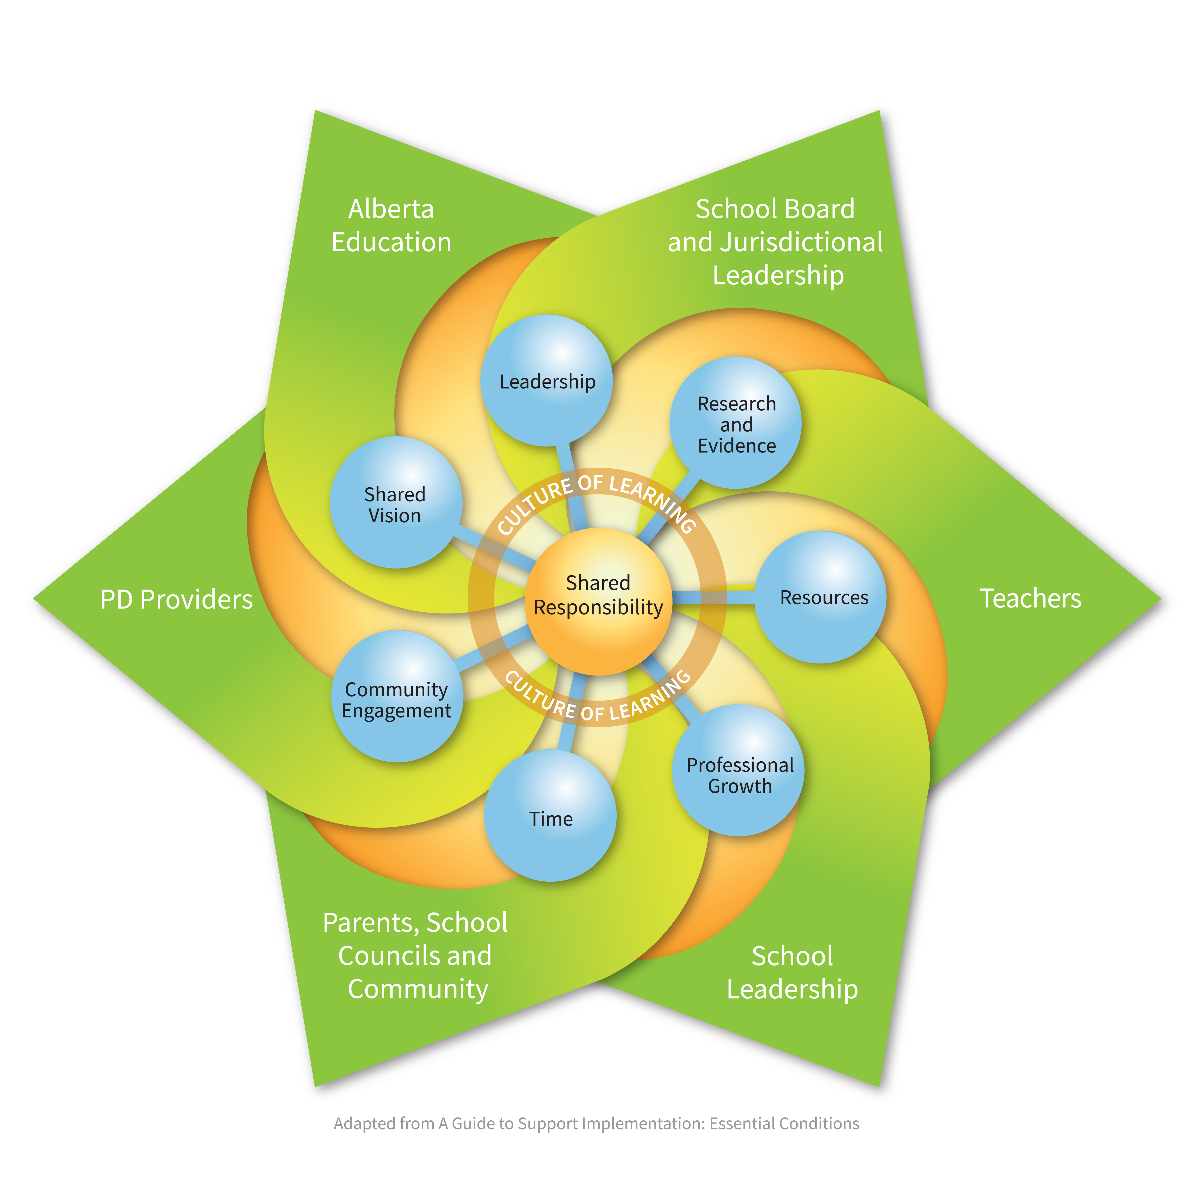
CASS strategic plan is designed for 2016-2019 and grant funding is provided until March 2018.

Adapted title - Professional Growth. A comprehensive approach to professional learning will be provided including various supports and services to meet diverse needs and contexts. (E.g., website supports online, self study and team materials, regional workshops, provincial conferences, zone meeting agenda items, personal consultation, print resources)

CASS will strive to work with other education stakeholders to develop a coordinated, collaborative and comprehensive plan to support and build professional capacity.

Alberta Education has provided grant funding to support implementation of the Superintendent Leadership Quality Standard through delivery of learning opportunities. CASS member’s resources are also accessed to support this work.

CASS Leaders will design and provide supports and services based on SLQS competencies, members' needs, district circumstances and resources available.

Superintendent leadership supports quality school leadership and teaching to create optimum learning for all students in Alberta
(Board approved June 2017)
CASS Strategic goal states: Leadership Capacity is built and supported.

Opportunities to communicate the work of Superintendents in Alberta will be heightened at the provincial level. Exploration of community contacts to engage with will occur.

AS CASS members build capacity for their own professional practice they will model a culture of learning.

Planning using A Guide to Support Implementation: Essential Conditions http://essentialconditions.ca/

This guide was developed based on the shared belief that successful implementation requires the coordinated, collaborative and comprehensive efforts of education partners working together towards a shared vision of learning success for all students (A Guide to Support Implementation: Essential Conditions, 2012). It is intended to support a process of collaborative conversation among education stakeholders working together to develop an implementation plan. It is designed with guiding questions to facilitate dialogue and planning.

This template offers selected questions for consideration in supporting implementation of the quality standards (adapted from A Guide to Support Implementation: Essential Conditions). It also provides space for you to record your group’s responses as a result of dialogue.

Shared Responsibility  - Who is affected by implementation of the quality standards?  - How are education stakeholders working toward a shared understanding of  and commitment to their respective roles and responsibilities to support implementation?  Shared Vision  - How is the shared vision developed collaboratively with and endorsed by stakeholders?  - Is the intent of the change, your preferred future, clearly articulated in the vision?  Leadership  - How is the capacity of current and future leaders being developed – including a focus on leadership competencies?  Research and Evidence  - What data, including current research, evidence and lessons learned, is being collaboratively and systematically collected and analyzed to support implementation planning and to assess the degree of implementation?  - How is understanding of effective professional learning modelled in the plan? How does the plan align with the change imagined?  - Does student learning data inform capacity building plans?  Resources  - What is your current capacity to support this change?  - How might this change be phased-in to optimize current capacity and available resources? | Superintendent Professional Growth  - How is information and data from adult learners about their needs coherent with the SLQS? Is this data used to inform professional learning design  - How might we design a more comprehensive approach for professional learning?  Time  - What is the overall implementation timeline?  - Are the stages of implementation considered?  Community Engagement  - How and who are the stakeholders engaged in supporting implementation?  - Are stakeholders meaningfully involved or just communicated to/with?  - Are there opportunities for both communication and more active involvement?  Student Learning  - How will you know if your implementation planning efforts are having an impact on and supporting student success?  Culture of Learning  - How are you fostering a culture of learning to optimize learning and success for all students?

