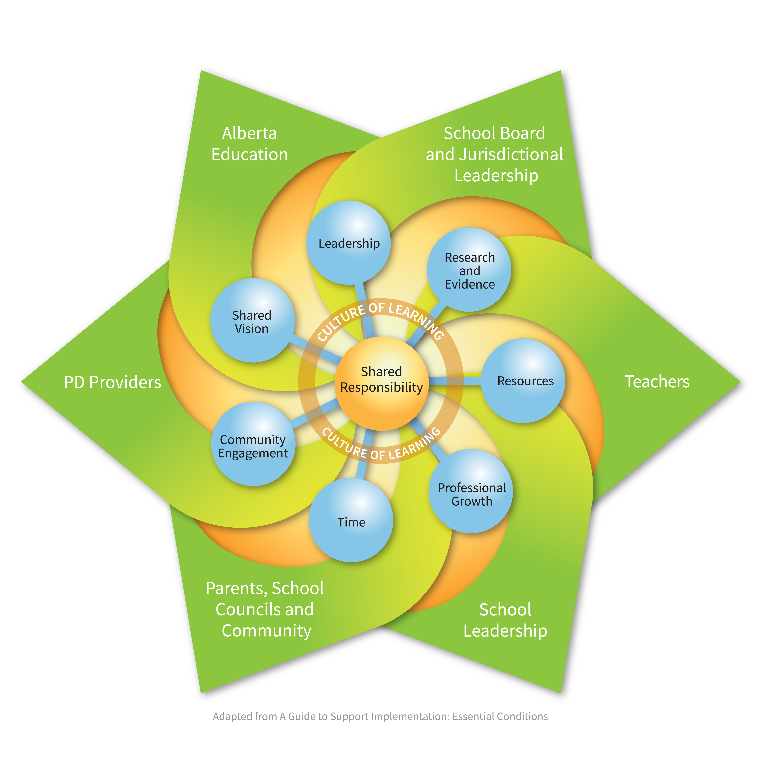

Planning using A Guide to Support Implementation: Essential Conditions http://essentialconditions.ca/

This guide was developed based on the shared belief that successful implementation requires the coordinated, collaborative and comprehensive efforts of education partners working together towards a shared vision of learning success for all students (A Guide to Support Implementation: Essential Conditions, 2012). It is intended to support a process of collaborative conversation among education stakeholders working together to develop an implementation plan. It is designed with guiding questions to facilitate dialogue and planning.

This template offers selected questions for consideration in supporting implementation of the quality standards (adapted from A Guide to Support Implementation: Essential Conditions). It also provides space for you to record your group’s responses as a result of dialogue.

Shared Responsibility  - Who is affected by implementation of the quality standards?  - How are education stakeholders working toward a shared understanding of  and commitment to their respective roles and responsibilities to support implementation?  Shared Vision  - How is the shared vision developed collaboratively with and endorsed by stakeholders?  - Is the intent of the change, your preferred future, clearly articulated in the vision?  Leadership  - How is the capacity of current and future leaders being developed – including a focus on leadership competencies?  Research and Evidence  - What data, including current research, evidence and lessons learned, is being collaboratively and systematically collected and analyzed to support implementation planning and to assess the degree of implementation?  - How is understanding of effective professional learning modelled in the plan? How does the plan align with the change imagined?  - Does student learning data inform capacity building plans?  Resources  - What is your current capacity to support this change?  - How might this change be phased-in to optimize current capacity and available resources? | Teacher Professional Growth  Principal Leadership Professional Growth  Superintendent Professional Growth  - How is information and data from adult learners about their needs coherent with the TQS, PLQS and SQS? Is this data used to inform professional learning design?  - How might we design a more comprehensive approach for professional learning?  Time  - What is the overall implementation timeline?  - Are the stages of implementation considered?  Community Engagement  - How and who are the stakeholders engaged in supporting implementation?  - Are stakeholders meaningfully involved or just communicated to/with?  - Are there opportunities for both communication and more active involvement?  Student Learning  - How will you know if your implementation planning efforts are having an impact on and supporting student success?  Culture of Learning  - How are you fostering a culture of learning to optimize learning and success for all students?

